Problems about docker machine

Q1 Unable to query docker version: Get https://192.168.99.100:2376/v1.15/version: x509: certificate is valid for 192.168.99.102, not 192.168.99.100

It appears when I use docker-machine ls

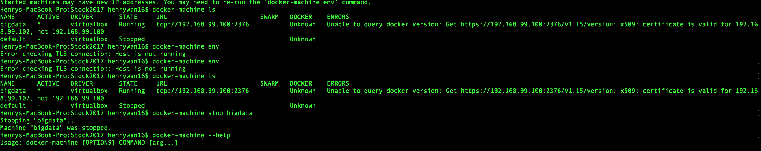

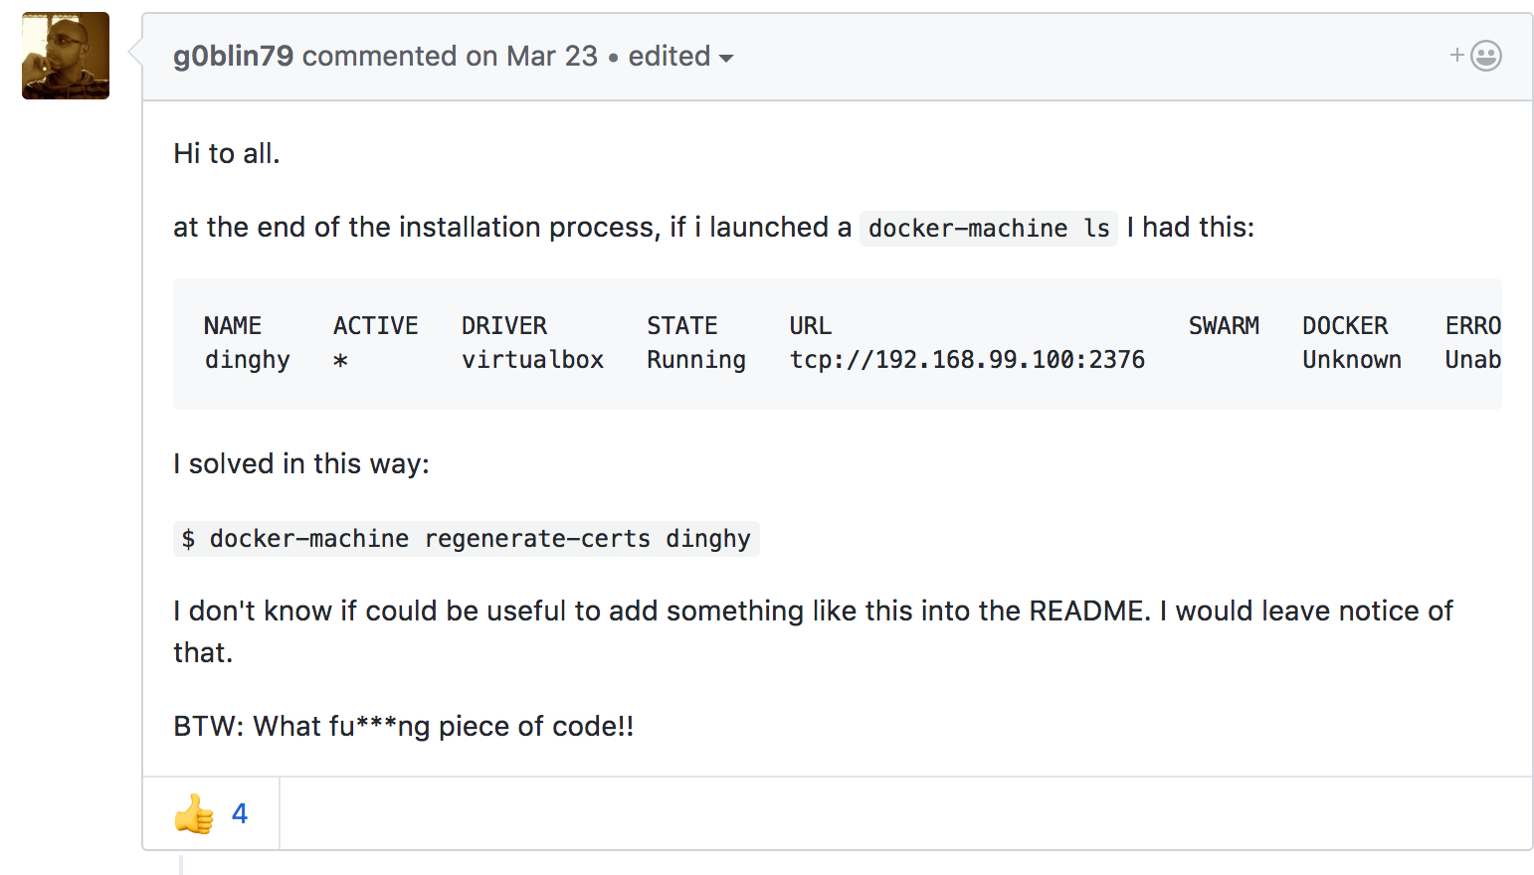

docker-machine stop default

docker-machine start bigdata

docker-machine regenerate-certs bigdata

Q2

docker run -d -p 2181:2181 -p 2888:2888 -p 3888:3888 --name zookeeper confluent/zookeeper

docker: Error response from daemon: Conflict. The container name "/zookeeper" is already in use by container "9eb9340d7a1d7f670b6c7a725e7c9291d70152665aab84e2f06bfbb71abef815". You have to remove (or rename) that container to be able to reuse that name.

See 'docker run --help'.

<https://community.hortonworks.com/questions/106067/the-container-name-sandbox-hdp-is-already-in-use-b.html>

docker rm -f $(docker ps -a -q)

sudo service docker restart

Q3

Unable to query